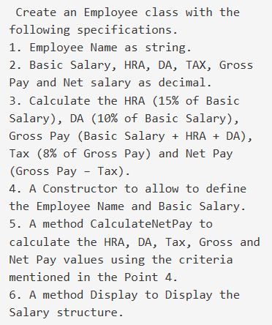

using System;

using System.Collections.Generic;

using System.Linq;

using System.Text;

namespace ConsoleApplication4

{

class Employee

{

string emp_name;

int bas_sal;

int HRA;

int DA;

int GDP ;

int TAX ;

double NS ;

Employee()

{

Console.WriteLine("Employee Name :");

emp_name = Console.ReadLine();

Console.WriteLine("Base sal :");

bas_sal= int.Parse(Console.ReadLine());

HRA = bas_sal * 15 / 100;

DA = bas_sal * 10 / 100;

GDP = bas_sal + HRA + DA;

TAX = GDP * 8 / 100;

NS = GDP - TAX;

}

void Display()

{

Console.WriteLine("Employee Name :" + emp_name);

Console.WriteLine("Base Salary :" + bas_sal);

Console.WriteLine("HRA :" + HRA);

Console.WriteLine("DA :" + DA);

Console.WriteLine("GDP :" + GDP);

Console.WriteLine("TAX :" + TAX);

Console.WriteLine("NS :" + NS);

}

static void Main()

{

Employee e = new Employee();

e.Display();

}

}

}

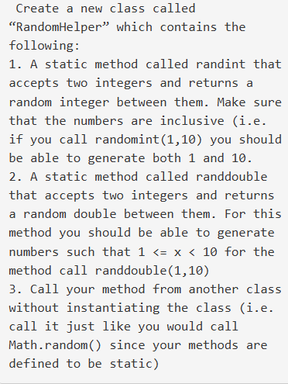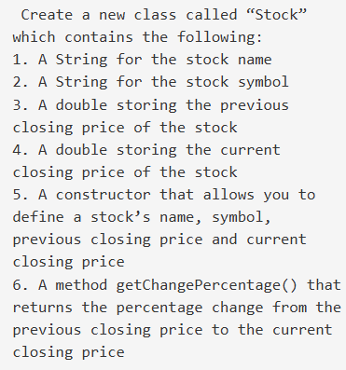

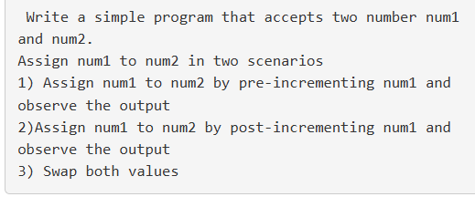

using System;

using System.Collections.Generic;

using System.Linq;

using System.Text;

namespace ConsoleApplication1

{

class Program

{

static void Main(string[] args)

{

int num1 = 5, num2 = 10;

Program p = new Program();

// Pre-increment operation

num2 = ++num1;

Console.Write("Case-1\n");

Console.Write("n1=" + num1 + "\n" + "n2=" + num2 + "\n");

// Post-increment operation

num2 = num1++;

Console.Write("Case-2\n");

Console.Write("n1=" + num1 + "\n" + "n2=" + num2 + "\n");

// Swapping values

p.swapping(ref num1, ref num2);

Console.Write("Case-3\n");

Console.Write("n1=" + num1 + "\n" + "n2=" + num2 + "\n");

}

void swapping(ref int num1, ref int num2)

{

int temp;

temp = num1;

num1 = num2;

num2 = temp;

Console.Write("Swapped In Function\n");

}

}

}

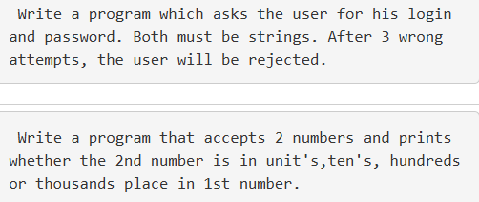

using System;

using System.Collections.Generic;

using System.Linq;

using System.Text;

namespace ConsoleApplication4

{

class Class1

{

static void Main()

{

for (int i = 0; i < 3; i++)

{

Console.WriteLine("Username");

String username = Console.ReadLine();

Console.WriteLine("Password");

String password = Console.ReadLine();

if (username == "184" && password == "hello")

{

Console.WriteLine("Login sucessful");

break;

}

else

{

Console.WriteLine("Invalid Mail or Password");

Console.WriteLine("Please Enter correct details");

}

}

}

}

}

